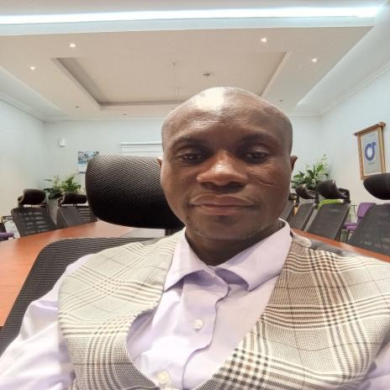

YAK
UBU
SEIDU
BAAH

PROFILE

Passionate educator with 7 years of
experience in teaching and
curriculum development. Committed
to creating engaging learning
environments and
fostering students’
growth. Skilled in lesson planning.
Classroom management, and
students’ assessment. Skilled in team
leadership, strategic planning, and
problem
-
solving.

CONTACT

PHONE NUMBER:

0597112125 / 0201385557

WEBSITE:

EMAIL ADDRESS:

Matthiasbaah8@Gmail.com

HOBBIES

Meditation

Listening to music

Reading

Sports

EDUCATION

UNIVERSITY OF CAPE OF COAST

2020
-
2022

BACHELOR IN EDUCATION

UNIVERSITY OF CAPE COAST

201
4
-
2016

DIPLOMA IN BASIC EDUCATION

WORK EXPERIENCE

NANCY INTERNATIONAL SCHOOL

-
HEADMASTER

2024
-
DATE

Provided

strategic leadership and management to the
school,
ensuring effective implementation of policies and programs.

JOSET INTERNATIONAL SCHOOL
-

HEADMASTER

2023
-
2024

Mentored

and supported teachers, promoting professional growth
and development. Ensured a safe and supportive learning
environment,
addressing
students’

discipline and welfare concerns.

NATIONAL SERVICES

AT KOTOKU M/A JHS
–

SOCIAL STUDIES TUTOR

2022
-
2023

Planning

and delivering lessons

Assessing students’ progress and performance and providing
feedback

Maintaining a positive classroom environment.

SKILLS

•

My experience in handling pupils, teaching the common
core program required under Ghana Education Service
(
G.E.S), abreast with pedagogical skills in teaching in all
levels of classroom teaching and learning activities
.

•

•

Ability to work for extra hours
with less or no supervision.

•

•

Computer knowledge in Tally, Ms
-
Word and Excel.

•

Effective writing and communication skills.

•

•

WORKSHOPS AND SEMINARS AND OTHER TRAINING

COACHING AND MENTORING FOR TEACHER (GA
-
WEST MUNICIPAL GHANA EDUCATION
SERVICE.

CERTIFICATE OF PARTICIPATION AND COMPLETION IN THE PIONEERS
-
RCC 2018(PIONERS
-
GHANA).

KAIROS COURSE ON CHURCH MISSIONS ICGC FAITH TEMPLE OFANKOR
-
ACCRA
.

CERTIFICATE IN MINISTERIALS ARTS
-
SCHOOL OF MINISTERIAL EXCELLENCE
-
KOGI STATE
-
NIGERIA. (2010
-
2013)

DECEMBER 2016
–

JANUARY 2019

DISTRICT

PASTOR
,
LAMBUSSIE ASSEMBLY
-

INTERNATIONAL CENTRAL GOSPEL CHURCH
.

Concerned with spiritual growth and development of members, empowering them to win souls and seeing
to the general wellbeing of all
.

REFEREES

REV. FIIFI NII OTABI WILSON, ICGC FAITH TEMPLE
-
OFANKOR ACCRA TEL;
0244388522
.

Pastor Seth _ pioneers
-
Ghana

TEL. 0242383049

TRANSFORMATION ASSEMBLY ICGC
–
DAWHENYA
-
ABBEY

PASTOR LAWRENCE KOJO DENNIS 0244380298

Rev.
Addition Evans
–

Nancy’s International School

TEL. 0244260238

PASTOR FRANCIS KOJO APEKE
–

Deeper Life Church

TEL; 0266641058

